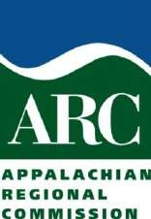

New York State
Appalachian Regional Commission

Area Development Program

DRAFT
APPLICATION GUIDANCE
Including NYS’s Implementing Strategies

For Projects Solicited for FFY 2020

INTRODUCTION

This document provides guidance to Local Development Districts (LDDs) and to project sponsors of proposed projects for which funding is requested under the Area Development Program of the Appalachian Regional Commission (ARC) for Federal Fiscal Year (FFY) 2020. This guidance also provides general information on program priorities, technical assistance contacts, and the application process and schedule for FFY 2020.

Appalachian Regional Development Organization and Authority

The ARC was established by the federal Appalachian Regional Development Act of 1965 to improve the economy and quality of life in the thirteen-state Appalachian Region. Governors of the Appalachian States and a Federal Co-Chair appointed by the President, comprise the Commission. The NYS Department of State (DOS) is the official agent of the State of New York for cooperating with the ARC in administering the Appalachian Regional Development Program, as specified in Article 6-B, Section 153 of NYS Executive Law. Deputy Secretary of State for Local Government Services Mark P. Pattison serves as the Governor’s Alternate for NYS’s Appalachian Area Development Program.

NYS receives an allocation of resources from the ARC each year to fund area development in NYS’s 14- county Appalachian Region. Appalachian New York’s counties are represented by one of three LDDs: Southern Tier West (STW) based in Salamanca, NY and comprised of Allegany, Cattaraugus, and Chautauqua counties; Southern Tier Central (STC) based in Corning, NY and comprised of Chemung, Schuyler and Steuben counties; and Southern Tier East (STE), in Binghamton, NY and comprised of Broome, Chenango, Cortland, Delaware, Otsego, Schoharie, Tioga and Tompkins counties.

The investment of ARC funds is guided by ARC's Strategic Plan 2016-2020 “Investing in Appalachia’s Future”1, which details five General Goals. The first three goals cover broad themes: economic opportunity, workforce development, and infrastructure modernization (including the completion of the Appalachian Development Highway System (ADHS), which, in NYS, is funded and administered by other federal and state agencies). The last two goals focus on natural and cultural assets and leadership and community capacity. All proposed Area Development projects in NYS must implement an ARC General Goal and one of the NYS Strategies contained in Section VI of this document.

Role of the LDDs

The LDDs work with their existing board members and a wide array of local participants to identify and prioritize economic development needs across the district and within local communities. Each LDD’s economic development priorities are articulated in an annual Comprehensive Economic Development Strategy (CEDS). Each LDD serves as a hub for regional planning and coordination and for developing collaborative community participation and civic leadership.

In addition, NYS’s LDDS are important partners to the New York State Regional Economic Development Councils (REDCs), which are public-private partnerships composed of local experts and stakeholders from business, academia, local government, and non-governmental organizations. REDCs are charged with developing long-term, locally-driven strategic plans and regional investment priorities for each of 10 distinct regions of NYS. These councils were created across NYS in 2011 to function as the cornerstone for statewide economic development efforts. (Appalachian NYS spans four REDCs but lies predominately within two of them – Western New York and Southern Tier. Otsego and Schoharie counties are in

1 http://www.arc.gov/images/newsroom/publications/sp/ARCStrategicPlan2011-2016.pdf

the Mohawk Valley REDC and Cortland County is in the Central New York REDC.) Each REDC’s economic development strategy is tailored to its region’s needs, opportunities and challenges. The LDDs have key roles on REDC work groups for their respective regions. Both the LDD’s CEDS and REDC’s economic development strategies are essential references for identifying higher priority projects for Area Development funding. Beyond these two references, regional and local comprehensive plans and other strategic plans are considered important documents that can elevate the ranking of proposed projects in the evaluation and selection process.

To leverage their regional planning capabilities and the related economic development focus of the ARC program, each LDD annually solicits from local not-for-profit organizations and municipalities regionally significant area development projects that will advance the goals and objectives of the ARC and one of NYS’s ARC Program’s implementing strategies. LDDs are encouraged to solicit a wide range of projects types, to provide technical assistance to potential project sponsors and to recommend projects for consideration by DOS for ultimate approval by the ARC. LDDs also assist project sponsors whose project proposal could be fully or partially funded through NYS’s Consolidated Funding Application (CFA) program. Applications not completed in close consultation with an LDD generally are not given favorable recommendations for consideration by DOS.

Construction projects must be administered by a “basic agency”. LDDs work with construction project applicants to identify a potential basic agency, such as U.S. Department of Agriculture/Rural Development (USDA/RD), which specializes on construction projects in rural areas. Other federal basic agencies include the U.S. Department of Commerce/Economic Development Administration (EDA) and the U.S. Department of Housing and Urban Development (HUD). NYS’s Department of Economic Development is a Registered State Basic Agency (RSBA) for projects involving funding from Empire State Development (ESD) and may be considered as a basic agency on a case by case basis with the prior consent of the agency. In addition, the Office for Community Renewal (OCR) may be authorized to serve as a non-federal basic agency to administer ARC construction projects on a case-by-case basis.

State Priorities for the 2019-2020 ARC Cycle

During the upcoming program cycle, DOS will seek out projects that emphasize the following priorities:

Advance the REDC’s strategies / priorities, the LDD’s CEDS, and county or community comprehensive plans. (All 3 is best.);
- Contribute measurably positive economic impact and advance economic development;
- Demonstrate job creation; or, alternatively, demonstratively retain local jobs;
- Train the workforce for employment in “wealth producing” careers;
- Promote Smart Growth (and/or village or urban center commercial revitalization); Foster rehabilitation of local pockets of distress*

*NOTE: Local pockets of distress are identified periodically by the ARC, which evaluates census tracts and counties of the Appalachian region against national averages for poverty rate, per capita market income and unemployment. Under this comparison, all Appalachian NYS counties except Allegany are categorized by ARC as economically “Transitional”, ranking in the middle 50 percentile of all counties in the nation. Allegany Co. is categorized as “At-Risk”, meaning that its economic condition is in the lower 25% of all U.S. counties. ARC will match up to 70% of project costs for “At-Risk” counties and up to 50% of costs for projects in “Transitional” counties. Although, several census tracts in Appalachian NYS fall into the bottom 25% of the nation’s, ARC match is determined only by the county’s economic category. More information on “pockets of distress” is available from the LDDs, DOS and the ARC.

NYS’s Smart Growth Public Infrastructure Policy Act

NYS enacted the Smart Growth Public Infrastructure Policy Act of 2010 (“Infrastructure Act”), Environmental Conservation Law §§6-0101 - 6-0111, to promote Smart Growth and sustainable infrastructure investments. The Act established ten Smart Growth criteria in NYS law, and infrastructure projects reviewed by NYS must meet those criteria “to the extent practicable.” State agencies and public authorities that approve or fund infrastructure projects are required to convene a Smart Growth Advisory Committee to ensure that funding and approval decisions for public infrastructure are consistent with the “relevant” Smart Growth criteria in the law. The agency’s advisory committees produce a Smart Growth Impact Statement after reviewing each project; if the project cannot practicably meet the Smart Growth Criteria, the agency must provide a written statement detailing the reasons the project fails to comply with such criteria.

The ten criteria of the Infrastructure Act can be broken down into two broad categories of land use: (a) “Where”, focusing on locations that maximize and strengthen existing communities and infrastructure; (b) “How”, concerning design features and planning processes that promote livability, sustainability, housing and mobility choices, environmental protection, equity, and broad-based community participation.

In summary, ten Smart Growth criteria used to review public infrastructure projects are:

- Maintenance and use of existing infrastructure: Similar to a “fix-it-first” policy, which focuses funding on repair and maintenance of existing infrastructure, rather than constructing new infrastructure.
- Location in “municipal centers”: Development and re-development in existing or new centers of activities – e.g., downtowns, Main Streets, central business districts, brownfield areas, local waterfront revitalization areas, environmental justice areas, hardship/low-income areas and transit- oriented development, among others.
- Infill development: Redevelopment, rehabilitation and development between existing buildings and on vacant, abandoned or underutilized properties.
- Natural resource protection: Preserving, protecting and enhancing water, air, agricultural land, forests, recreation, open spaces, scenic areas and historic/archaeological resources.
- Smart Growth planning and design principles: Includes density, mixed-uses, public spaces, diverse housing choices near employment and other amenities and age- and income-integration.
- Mobility and transportation choices: Reducing car-dependence through walkable, bikeable, transit- friendly neighborhood design and street connectivity.
- Inter-governmental coordination: Regional, inter-municipal and state/local coordination.
- Community-based planning: Projects that result from inclusive, bottom-up, stakeholder-driven planning processes.
- Predictability and reliability in building and zoning codes: Clear codes that promote smart growth and are consistently and predictably applied.
- Sustainability development: Projects that use existing resources in ways that do not compromise the needs of future generations – e.g., reducing greenhouse gas emissions, promoting broad-based public participation and adequate governance structures to ensure and maintain sustainability.

Smart Growth has been recognized to promote economic and fiscal sustainability. Research is showing that businesses value quality-of-life factors – such as vibrant downtowns and outdoor recreation and open space
– in deciding where to locate, in part to attract the young talented workers who are fueling the New Economy. Infrastructure investments that induce Smart Growth provide a greater return on the public

investment – that is, they are more likely than sprawling development to pay for themselves in tax revenues and economic activity. In this fiscal and economic climate, sustainable infrastructure and land use investments can go a long way toward managing strained municipal budgets.

Communities affected by development projects related to the I-86 corridor are recommended to incorporate Smart Growth principles into local and regional land use decision-making and planning, zoning and project development processes. This can be accomplished in part by designating nodes for concentrated (ideally mixed-use) development in areas most appropriate for such development. Land use and infrastructure investments in municipal centers and other previously developed areas can help enhance and create Smart Growth-type development. This type of development – if designed properly – can create vibrant, livable and sustainable communities. Localities can also integrate their land use and capital / infrastructure plans to reflect Smart Growth principles and sustainable land use patterns that reinforce one another.

Infrastructure Construction Project Impact Statement Procedures

ARC project applications that involve infrastructure construction must be accompanied by a NYS Smart Growth Public Infrastructure Policy Act Compliance Questionnaire. This form is available from the LDD or via DOS’s ARC program website. If a project proposal is being reviewed by another “State Infrastructure Agency”, the information must be noted in the applicable section of the questionnaire. If another NYS agency has already completed its Smart Growth Review, the applicant has the option of submitting a copy of the other agency’s Smart Growth Review opinion, if available, with the grant application for consideration by DOS’s Smart Growth Review Committee.

NYS’s ARC program staff will forward the application and questionnaire to NYS’s Director of Smart Growth Planning and to DOS Office of Counsel for a preliminary review and draft Impact Statement. During this process, the applicant and NYS’s Director of Smart Growth Planning may potentially identify modifications to the proposed project that could bring non-conforming work plans into better compliance with the Infrastructure Act principles. Once a proposed project is ready for submission to DOS’s Smart Growth Advisory Committee, DOS’s Office of Counsel will forward the final application and Impact Statement to that Committee for a final opinion on the suitability of the proposed project. Projects that are consistent with the Smart Growth goals will be eligible for DOS approval and submission to the ARC if all other project ranking conditions and requirements are in place. Project proposals that are not deemed to be in complete compliance with the Smart Growth criteria may be returned to the LDD with comments suggesting changes that might allow the project to achieve compliance with Smart Growth Policies.

“Energy Efficient Efforts” (Construction Projects)

ARC construction proposals should include a discussion of the energy efficient features of the project and/or describe efforts made to improve the energy efficiency of the project, including a discussion of features that were considered but were not included. Three major categories, Technology, Design, and Materials should be covered. Technology may include the use of equipment that allows for greater energy efficiency, lower operating costs, greater durability and increased output over conventional equipment. Design comments explain efficiency elements designed into the project plan. Materials used comments should explain how recycled or renewable materials have been incorporated, how low impact materials (such as low to no VOC content chemicals, natural dyes and components) are selected over alternatives, and how porous paving, indigenous landscaping and other features make the project more energy efficient and minimize environmental impacts.

TECHNICAL ASSISTANCE CONTACTS

  - Local Development Districts (LDDs) and Counties Served

Allegany Cattaraugus Chautauqua | Southern Tier West Regional Planning and Development Board 4039 Route 219, Suite 200  Salamanca, New York 14779 (716) 945-5301; Fax (716) 945-5550
 | www.southerntierwest.org
 | EXECUTIVE DIRECTOR – Richard T. Zink
 | PROGRAM CONTACT – Craig Klose
 | E-mail: cklose@southerntierwest.org
Chemung Schuyler Steuben | Southern Tier Central Regional Planning and Development Board 8 Denison Parkway East, Suite 310  Corning, New York 14830 (607) 962-5092; Fax (607) 962-3400
 | www.stcplanning.org
 | EXECUTIVE DIRECTOR – Chelsea Robertson
 | PROGRAM CONTACT – Victoria Ehlen
 | E-mail: Vehlen@stcplanning.org
Broome | Southern Tier East Regional Planning Development Board 49 Court Street, Suite 222 (2nd Floor)  Binghamton, New York 13901 (607) 724-1327; Fax (607) 724-1194  www.southerntier8.org  DIRECTOR – Jennifer Gregory  PROGRAM CONTACTS  Oneonta Office: Jaclyn Courter JCourter@southerntier8.org  Binghamton Office: Joann Lindstrom JLindstrom@southerntier8.org
Chenango
Cortland
Delaware
Otsego
Schoharie
Tioga
Tompkins

New York State (NYS)
Appalachian Regional Commission (ARC)
Area Development Program
Implementing Strategies
Federal Fiscal Year 2020

Appalachia and the New York State Appalachian Region

The Appalachian Regional Commission (ARC) is a state and federal partnership concerned with the socio-economic development of the Appalachian Region of the United States. Established by an act of Congress in 1965, ARC has progressed over the past 46 years to become a model for regional economic development. The 205,000-square-mile federally-designated Appalachian Region extends more than 1,000 miles along the spine of the Appalachian Mountains from southern New York to northern Mississippi. The U.S. Appalachian Region is comprised of 420 counties and is home to 24.8 million people. The ARC’s leadership consists of the governors of the 13 Appalachian states, appointed state Alternates, and the Presidentially- appointed Federal Co-Chair.

The NYS Appalachian Region, also known as NYS’s “Southern Tier” (and as “the Region” where the context is appropriately clear), consists of fourteen counties extending approximately 285 miles from eastern Schoharie County to the southwestern corner of Chautauqua County. (See Map 1.) The Region covers 24.8 percent of the State’s total land area and has a population of slightly more than one million, which represents about 5.5 percent of NYS’s total population. Roughly half of the Region’s residents live in or around medium to small cities or villages with the largest population clusters located around the cities of Binghamton (Broome County), Elmira (Chemung County), Ithaca (Tompkins County), Cortland (Cortland County), and Jamestown (Chautauqua County).

Local- level leadership and participation in the ARC Program is coordinated through multi-county local development districts (LDDs). NYS’s ARC Program is co-administered by three LDDs (also known as “regional planning and development boards”) as follows (constituent counties are noted in parentheses):

- Southern-Tier Eight (Broome, Cortland, Chenango, Delaware, Otsego, Schoharie, Tioga, and Tompkins), headquartered in Binghamton (Broome Co.);

- Southern-Tier Central (Chemung, Schuyler, and Steuben), headquartered in Corning (Steuben Co.);

- Southern-Tier West (Allegany, Cattaraugus, and Chautauqua), headquartered in Salamanca (Cattaraugus Co.).

NYS Executive Law §153(d) (2) designates the NYS Department of State (DOS_ as:
“…. the official agent of the state for the purpose of administering, carrying out and otherwise cooperating with the federal government in connection with the provisions of the federal Appalachian regional development act of nineteen hundred sixty-five as heretofore and hereafter amended; to apply for, accept, and expend funds made available by the federal government pursuant to such federal acts and enter into any necessary contracts or compacts in connection therewith; and to take any further action which may be required under the terms of any such federal act.”

Map 1: Boundaries of Appalachian New York State and New York State’s LDDs
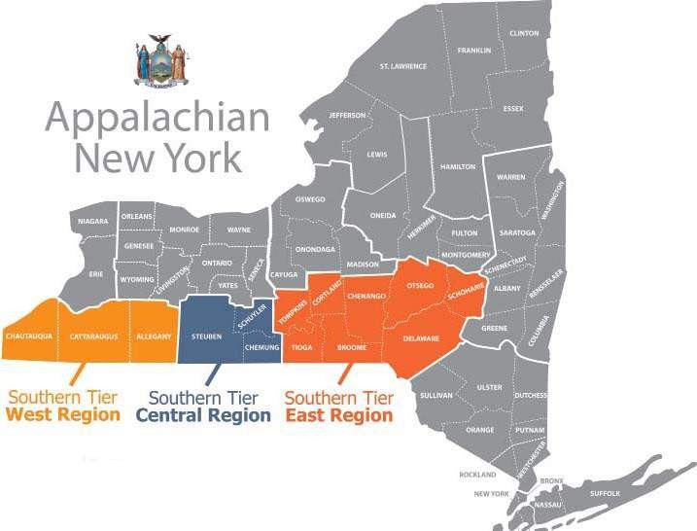

Strategic Overview
The following five investment goals are identified in ARC’s Strategic Plan, “Investing in Appalachia’s Future: The Appalachian Regional Commission’s Five-Year Strategic Plan for Capitalizing on Appalachia’s Opportunities 2016 − 2020”1:
:

Goal 1: Economic Opportunities
Invest in entrepreneurial and business development strategies that strengthen Appalachia’s economy.

Goal 2: Ready Workforce
Improve the education, knowledge, skills, and health of residents to work and succeed in Appalachia.

Goal 3: Critical Infrastructure
Invest in critical infrastructure—especially broadband; transportation, including the Appalachian Development Highway System; and water/wastewater systems.

Goal 4: Natural and Cultural Assets
Strengthen Appalachia’s community and economic development potential by leveraging the Region’s natural and cultural heritage assets.

Goal 5: Leadership and Community Capacity
Build the capacity and skills of current and next‐generation leaders and organizations to innovate, collaborate, and advance community and economic development.

1 http://www.arc.gov/about/ARC2016-2020StrategicPlan.asp

These goals and their implementing strategies are each closely aligned with the priorities of New York State’s ten Regional Economic Development Councils (REDCs), which were established to transform the statewide approach to long-term economic development. REDCs are composed of local experts and stakeholders from business, academia, local government, and non-governmental organizations, and have been tasked to develop strategic plans that emphasize each region’s strengths and unique assets. (See Map 2.)
Map 2: New York State Regional Economic Development Councils
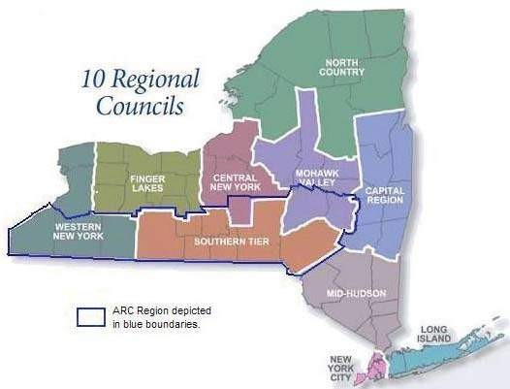

The REDC process is closely correlated with ARC’s approach to economic development that emphasizes local decision-making.
Prospective applicants are advised to collaborate with their LDD and REDC and to explore co-funding opportunities through the NYS’s Consolidated Funding Application (CFA) grants program. ARC Area Development project proposals are expected to match the planned priorities of the constituent REDC and LDD, and to implement one of the supporting NYS Implementing Strategies related to an ARC Investment Goal. Projects that have been proposed in the REDC’s strategic plans and/or the LDD’s Comprehensive Economic Development Strategy (CEDS) are likely to receive preference by NYS’s ARC Program when making recommendations for funding from the ARC.

NYS GOALS AND STRATEGIES

This Section identifies the NYS strategies to guide the investment of ARC resources in the NYS Appalachian Region. The strategies were established for NYS’s ARC Program in response to ARC’s Strategic Plan “Investing in Appalachia’s Future: The Appalachian Regional Commission’s Five-Year Strategic Plan for Capitalizing on Appalachia’s Opportunities 2016 - 2020”.

NYS’s ARC Area Development Implementing Strategies

Each of the ARC’s Investment Goals has been matched with Implementing Strategies for NYS’s ARC Program that have been adapted to meet the needs of the NYS Appalachian Region. Applications for ARC Area Development funding for projects in NYS must address one of the ARC’s five Investment Goals and one of NYS’s related Implementing Strategies as explained herein. NYS programs related to the ADHS in NYS are administered by NYS Department of Transportation (DOT). Applications will be submitted to DOC via the LDD in which the project sponsor is based or where the majority of project benefits will be seen.

Outcome Measurements

All ARC Area Development grant applications must articulate measurable economic development benefits to be derived within three years of project completion, and other outputs and outcomes related to the goal and strategy that projects address. The following additional performance targets are relevant to each of the ARC Investment Goals2:

- Goal 1 targets project outcomes that create and strengthen businesses, create and retain jobs, and leverage private investment. Relevant outputs include numbers of businesses assisted and/or created, numbers of full-time jobs created and/or retained, and dollar of additional regional investment resulting from an ARC project.
- Goal 2 targets project outcomes that educate and prepare students and workers to participate in the Region’s economic opportunities. It also addresses outcomes that expand access to health programs for the Region’s residents. Number of students or participants served/graduated, and health outcomes or workers improved should be estimated.
- Goal 3 targets project outcomes that improves infrastructure for businesses and households. Measures of infrastructure outcomes should include dimensions of infrastructure improved and numbers of residences and businesses improved.
- Goal 4 targets project outcomes that create or strengthen local businesses through initiatives tied to tourism / asset development. Typical output estimates include the percentage and number of new daily and overnight visitors project deliver and the percent and dollar value of regional revenue increases generated.
- Goal 5 targets project outcomes that strengthen communities, develop local leaders and enhance community capacity. Typical outcomes include numbers of community participants improved and dollar values of efficiencies created, or additional funding provided to communities resulting from such ARC projects.

2 https://www.arc.gov/images/newsroom/publications/guidelines/ARCProjectGuidelines.pdf

ARC INVESTMENT GOAL 1: Economic Opportunities

Invest in entrepreneurial and business development strategies that strengthen Appalachia’s economy. Increase Job Opportunities and Per Capita Income in Appalachia to Reach Parity with the Nation
NYS Condition: The NYS ARC Program emphasizes three themes related toward this goal: 1) fostering the capacity of communities to leverage their resources to plan regionally and to raise funds to complete regionally significant projects, 2) working with the REDCs and county leaders to identify projects that will have a transformative impact toward developing the regional economy, and 3) collaborating across government and program boundaries to accelerate the growth of the Region’s economic base.

NYS Implementation Strategies to Promote Economic Opportunities:

Strategy 1.1: Encourage and support entrepreneurship and local business development through technical assistance, incubation and acceleration, capital access, mentoring, networking, business‐ownership transition, and other types of support.
Rationale: Locally-owned businesses need an environment that encourages and supports entrepreneurship and business development through technical assistance, incubation and acceleration, capital access, mentoring, networking, business‐ownership transition, and other types of support.

Strategy 1.2: Support the growth and startup of high-potential businesses, particularly in targeted sectors that build on local and regional assets. This includes, but is not limited to: advanced manufacturing, clean energy, health care, high-technology, tourism, agriculture and local food systems.
Rationale: Supporting entrepreneurship and business development in targeted sectors that have growth potential and that build on local and regional assets provides the greatest opportunity for building a strong regional economy. These businesses also offer better job opportunities for Appalachia’s workers. Targeted sectors can include manufacturing, diversified energy, tourism, local food systems, and health care, as well as other sectors with growth potential.

Strategy 1.3: Enhance the competitiveness of the Region’s manufacturers.
Rationale: The region’s historically strong manufacturing sector offers significant potential for growth. Developing networks and supporting innovative manufacturing processes and business plans will enhance the sector’s economic competitiveness.

Strategy 1.4: Promote strategies to connect start-up and established businesses to global markets.
Rationale: Today’s global marketplace provides the opportunity to sell goods and services on a much broader scale. Demand from outside the Region for goods and services has strong potential for growth. Helping Appalachian businesses tap into this growing external demand will contribute to their long‐term success.
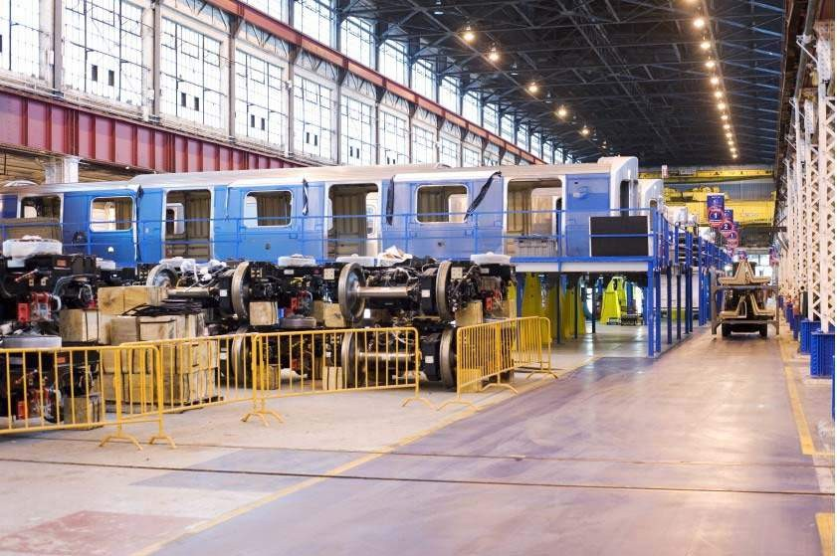
Alstom Transport North America in Hornell is the largest passenger rail manufacturing facility in North America and has been in operation for over 150 years.

ARC INVESTMENT GOAL 2: Ready Workforce

Improve the education, knowledge, skills, and health of residents to work and succeed in Appalachia
NYS Condition: A healthy, skilled, and ready workforce is a building block for a more prosperous Appalachian Region. NYS’s REDCs and LDDs have identified workforce development as a key objective toward getting the Region’s economy operating at a high level. NYS’s ARC Program will emphasize strategies that: foster better matches between the Region’s workforce and opportunities presented by local employers; increase educational opportunities; promote public health; address health professional shortages; and lowers barriers to employment to achieve maximum workforce participation.

NYS Implementation Strategies to Promote Ready Workforce:

Strategy 2.1: Develop and support educational programs and institutions that contribute to a better educated workforce prepared for 21st Century careers.
Rationale: Education, particularly post-secondary education, is a key component of the business and entrepreneurial ecosystem and often a primary economic driver. Investments to connect education, workforce, and business interests in a seamless system that prepares the Region’s young people to succeed in existing and emerging sectors and creates new opportunities for workers transitioning to new employment is essential. These efforts must begin with strong educational programming and institutions, and ensure that all students have the basic skills, as well as the soft skills, needed for productive employment or entrepreneurship. Emphasis will be placed on providing education and training matched to the Region’s current sectors and jobs, while increasing access to advanced skills training for the jobs of the future.

Strategy 2.2: Support programs that provide basic and soft skills training to prepare workers for employment, reentry into the workforce, or to transition to sectors that are experiencing growth and that provide opportunities for advancement
Rationale: A ready workforce includes workers that have basic knowledge and skills—such as literacy, numeracy, and problem solving—to succeed in the workplace. In addition, workers need soft skills—such as communication, time management, and interpersonal skills—to obtain and maintain employment. Investing in activities that build the basic and soft skills of the workforce will help retain, attract, and grow businesses. Further, as a large portion of the population has been out of the workforce due to a wide range of causes, NYS will support efforts of BOCES and other organizations to prepare inactive or displaced workers for reentry into the workforce and to promote the skills needed for growth-oriented sectors of the region’s economy.

Strategy 2.3: Increase local residents’ access to STEAM and other skills training on state-of-the-art technology and processes across all educational levels.
Rationale: To take advantage of new employment opportunities prospective workers must have access to and engage in career‐specific education and skills training that can help them succeed and advance in their careers. A number of emerging sectors require a workforce with strong science, technology, engineering, arts, and math (STEAM) skills. For workers to take advantage of employment opportunities in growing sectors, they must have both the foundational knowledge and the relevant technological skills needed to succeed.

Strategy 2.4: Improve access to affordable, high-quality health care for workers and their families.

Rationale: Many parts of Appalachia, particularly economically distressed areas, are underserved by health‐care professionals and health‐care facilities. Investments that increase access to quality, affordable health care are critical to the Region, as a healthy workforce is essential for Appalachia to compete in today’s economy.

Strategy 2.5: Support public health practices and sustainable clinical services that address health conditions that affect the Region’s economic competitiveness.
Rationale: The workforce can be better prepared by reducing high rates of chronic disease and by innovative initiatives that improve the health of the Region’s residents to ensure a ready and able workforce.

Strategy 2.6: Develop and support sustainable programs that remove barriers to participating in the workforce.
Rationale: Access to reliable transportation, affordable elder or child care, and primary health services can improve workforce participation. Developing and supporting programs that are specifically designed to increase workforce participation will help ensure a ready and able workforce.
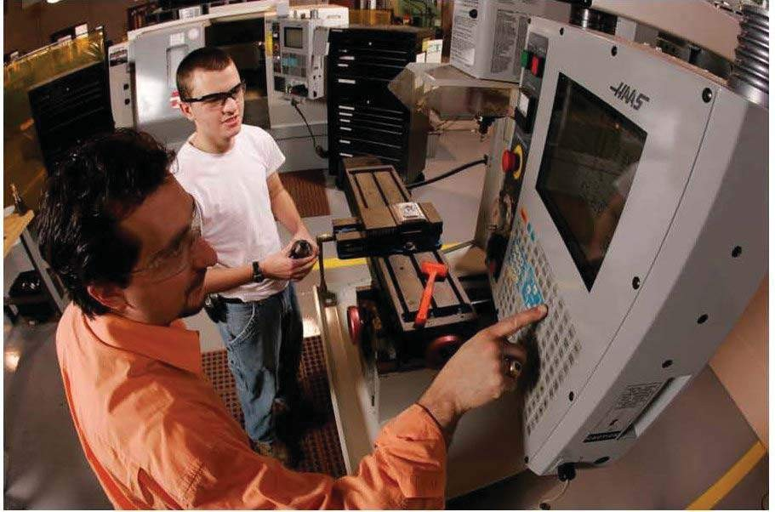

Jamestown Community College’s Manufacturing Technology Institute was funded in part with ARC grants.

ARC GENERAL GOAL 3: Critical Infrastructure

Invest in critical infrastructure—especially broadband; transportation, including the Appalachian Development Highway System; and water / wastewater systems
NYS Condition: To attract businesses investment and workers into the Region, investment in critical infrastructure — especially broadband; transportation, and water/wastewater systems is essential. NYS has articulated several areas for emphasis: Telecommunications and Broadband Connectivity; Community Revitalization; Intermodal Transportation connections to the ADHS; and healthy efficient Water/Wastewater systems. In addition, brownfield remediation will be encouraged in cooperation with the state’s Brownfield Opportunity Areas Program.

** IMPORTANT NOTE: All projects related to investment of ARC funds for the ADHS in NYS are administered by NYS Department of Transportation ( DOT) via direct FHWA funding assistance, which is a decreasing source of funds as NYS’s ARC-funded ADHS corridors are complete. DOT provides technical assistance regarding other transportation projects and policies for NYS’s ARC Region.

NYS Implementation Strategies to Improve Critical Infrastructure:

Strategy 3.1: Promote the productive and strategic use of broadband and telecommunications infrastructure throughout the Region to increase connectivity and strengthen economic competitiveness.
Rationale: Telecommunications infrastructure can help reduce Appalachia’s isolation and connect its communities with information and markets around the world, but many of the Region’s communities, particularly those in distressed counties and areas, lack access to reliable and affordable telecommunications infrastructure. Investing in telecommunications for these communities, and supporting its productive use, will help strengthen Appalachia’s economic competitiveness.

Strategy 3.2: Ensure communities have the adequate basic infrastructure (water, sewer, diversified energy, and housing) they need to implement their community and economic development objectives.
Rationale: Communities need adequate water and wastewater systems, diversified energy sources, and quality affordable housing to sustain businesses, generate jobs, protect public health, and ensure a basic standard of living for residents. Many Appalachian communities continue to lack this basic infrastructure, compromising their ability to pursue broad community economic development objectives. Investing in basic infrastructure that can help advance local community and economic objectives is an investment in the economic potential of the Region, as well as in the health of its residents.

Strategy 3.3: Support the construction and adaptive reuse of business development sites and public facilities to generate economic growth and revitalize local economies.
Rationale: Communities must have adequate sites and facilities, tailored to the specific needs of the Region’s growing sectors, to sustain and grow the businesses that generate local jobs. Investing to create and improve technology centers, incubators, shared work spaces, and commercial, industrial, health‐ care, creative, and educational sites and facilities, and to reclaim and reuse brownfields, is an important community economic development strategy.

Strategy 3.4: Strengthen links between transportation networks and economic development; invest in intermodal transportation planning and infrastructure that builds on the ADHS and maximizes the Region’s access to domestic and international markets.
Rationale: The Appalachian Development Highway System in NYS has significantly reduced the Region’s isolation and opened opportunities for economic growth. Now to compete in a global economy, the region needs reliable access to domestic and international markets. Connecting the ADHS to rail, waterway, and aviation routes can help link the region to these markets.
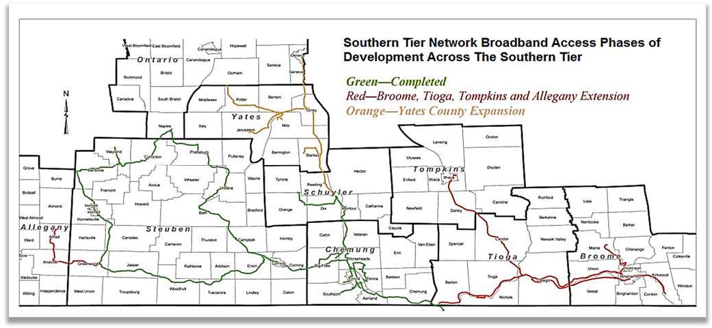
Southern Tier Network, Inc. (STN), a not-for-profit, open access optical fiber network, was created through a partnership of Southern Tier Central Regional Planning & Development Board, Corning Incorporated, and Chemung, Schuyler, and Steuben Counties with assistance from ARC funding. Its 260-mile fiber backbone ring is now complete and fully operational.

ARC INVESTMENT GOAL 4: Natural and Cultural Assets

Strengthen Appalachia’s community and economic development potential by leveraging the Region’s natural and cultural heritage assets.

NYS Condition: NYS’s Appalachian Region encompasses 11,681 sq. miles, or approximately 24.7% of NYS’s total 47,126 sq. mile area. The Region also represents approximately 5.7% of the Federal Appalachian Region’s land area. Approximately 285 miles long from west to east and approximately 41 miles from north to south. It contains historic urban areas surrounded by miles of rural space. Within this area are headwaters of major drainage basins, including the Ohio/Mississippi Rivers, the Delaware River, the Mohawk/Hudson Rivers and the Finger Lakes/Great Lakes. Excellent agricultural assets and centuries of technological innovation have imbued the Region with unique cultural assets. NYS is committed to asset-based development initiatives that will make the most of the Region’s unique natural and cultural assets.

NYS Implementation Strategies to Promote Natural and Cultural Assets:

Strategy 4.1: Preserve and strengthen existing natural assets in support of economic opportunities that generate local and regional benefits.
Rationale: Natural assets, such as forests, land, water, and mountains, provide a strong base for the Appalachian economy. Providing for responsible stewardship of these assets can unlock even greater economic development potential for the Region.

Strategy 4.2: Preserve and strengthen existing cultural assets, such as unique historic, artistic, and heritage sites through strategic investments that advance local and regional economic opportunities.
Rationale: Investments that strengthen cultural assets, such as helping maintain cultural traditions and improving or developing unique historic, artistic, and heritage sites—all of which attract tourists, new residents, and businesses to the Region—should be connected to strategic economic development opportunities.

Strategy 4.3: Support strategic plans and investment in building connections to and between the Region's natural and cultural resources.
Rationale: Strategic investment in activities such as developing and connecting regional multi‐use trails and cultural heritage sites generates interest from residents and tourists alike and results in substantial economic impact in the Region.

Strategy 4.4: Support preservation and stewardship of downtown communities, historic districts, and main streets to advance local economic growth.
Rationale: Strategic investments in downtown redevelopment, gateway communities, historic districts, and other unique community features can help revitalize and enrich local economies.

ARC INVESTMENT GOAL 5: Leadership and Community Capacity

NYS Condition: NYS’s ARC program is housed within DOS’s Division of Local Government which coordinates a series of leadership and community capacity programs including the Local Government Efficiency (LGE) Program and the Local Government Technical Assistance and Training Program. In addition, DOS works with the LDDs to promote community capacity and works with other DOS agencies to promote planning and leadership development and community capacity. The following strategies will implement Goal 5.

Strategy 5.1: Develop and support robust inclusive leadership that can champion and mobilize forward-thinking community improvement.
Rationale: Economic transition calls for innovative leaders who think long-term and offer effective strategies for community improvement. Communities need leadership that reflects their demographics, understands the local economic context, and is skilled in communication, collaboration, consensus building, and community engagement.

Strategy 5.2: Help develop civic leadership skills and community capacity at the local and regional level, especially among youth and next-generation leaders.
Rationale: Young leaders are critical to the future of Appalachia. Providing the next generation with meaningful leadership and engagement opportunities at the local and regional levels will motivate them to stay in the Region—establishing careers, creating businesses, and otherwise contributing to community and economic development.

Strategy 5.3: Strengthen the capacity of community organizations and institutions to articulate and implement a vision for sustainable, transformative community change.
Rationale: Community organizations and institutions are integral parts of local communities. Their leadership can help create and implement a vision for community change. However, particularly in economically distressed counties and areas, community organizations and institutions have limited capacity to engage in long-term community improvement efforts. Support is needed to build organizational resources and skills so these entities can have a greater impact in the community.

Strategy 5.4: Support visioning, strategic planning and implementation, and resident engagement approaches to foster increased community resilience and generate positive economic impacts.
Rationale: Long-term visioning and strategic planning by local and regional leadership provide a way forward for the region's communities. NYS's Local Development Districts and Regional Economic Development Councils are key partners to NYS's ARC Program. Including residents in community planning processes is important, as they can identify strategies suited to the local culture and economy. In addition, residents involved in planning and contributing to the creation of a common vision are more likely to support and engage in implementing the vision.

Strategy 5.5: Develop and support networks, partnerships, and other models of collaboration that catalyze public, private, and nonprofit action for community impact.
Rationale: It will take many partnerships across business, government, nonprofit, and philanthropic organizations to advance Appalachia’s economy. These collaborations attract investments and produce greater impacts, helping move the Region’s economy forward.

Strategy 5.6: Provide technical assistance and referrals to communities so they have the capacity and connections needed to pursue community development opportunities.
Rationale: As a multi-disciplinary economic development program, NYS's ARC Program can leverage its resources to assist local governments in multiple ways and to foster connections that enhance community capacity, including through training of community leaders and in opening communications between communities and other resource providers that can advance the goals and objectives of the ARC's strategic plan.

Strategy 5.7: Assist municipalities to leverage funding opportunities and to maximize efficient delivery of services and provide access to information and technical assistance that supports this strategy.
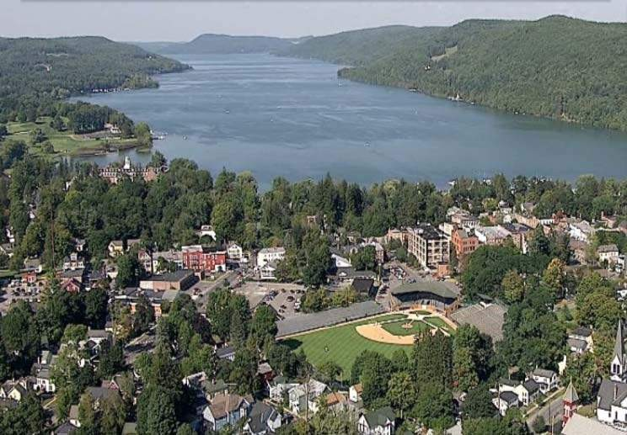
Rationale: Strong local governments are characterized by efficient delivery of services. NYS's ARC Program will work with all levels of local government to ensure that communities have the capacity to deliver needed services efficiently so that they can attract private investment and retain and grow their local populations.
Otsego Co. has seen many collaborations between NYS’s ARC and Local Government Efficiency Programs. Its Career Opportunities in Rural Education (CORE) initiative shares services for STEM education across multiple school districts.

